Casio CZ-101 (1984)

Theme:

Chord Keyboards  
From music to type

Chord keyboards require 2 or more keys to be simultaneously pushed to spawn the intended output. Playing a chord on a piano or pushing both the shift + a letter key on a typewriter to enter an upper case character are examples.

Grandjean Sténotype (1910)

This is an early mechanical keyboard for taking dictation. Instead of typing alphanumeric characters as on a typewriter, pressing different combinations prints shorthand symbols on the tape, each representing a different phoneme. Speech is easier to keep up with this way, since each phoneme typically represents multiple characters.

The downside – until AI came to the rescue – was that it then took hours to manually transcribe to shorthand into conventional readable text.

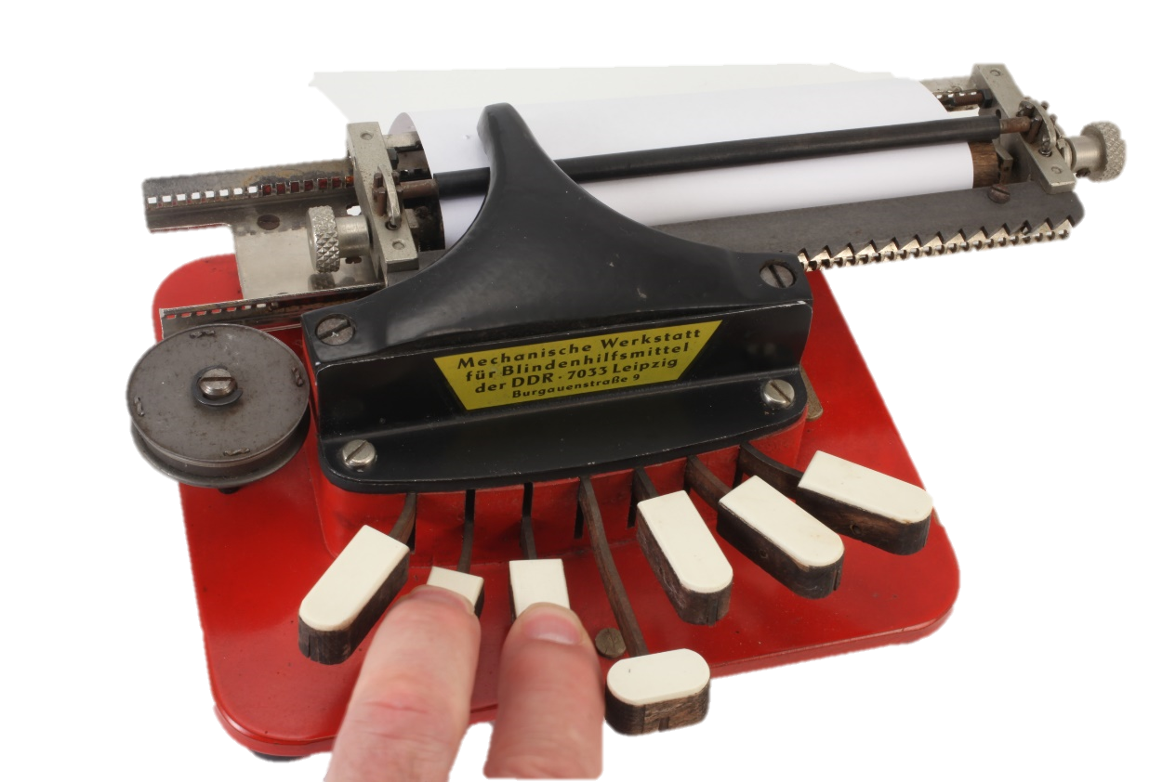

MWB Braille Writer (1980)

Designed and manufactured in the DDR, the purpose of this keyboard is to emboss dots representing Braille symbols onto paper. The effect is to enable blind users to use their tactile sensitivity to read with their fingers.

Each Braille symbol consists of two columns of 3 embossed dots each. Which 3 dots are embossed in each column is determined by which of the three keys on either side are simultaneously pressed. The key in the middle, operated by either thumb, enters a space.

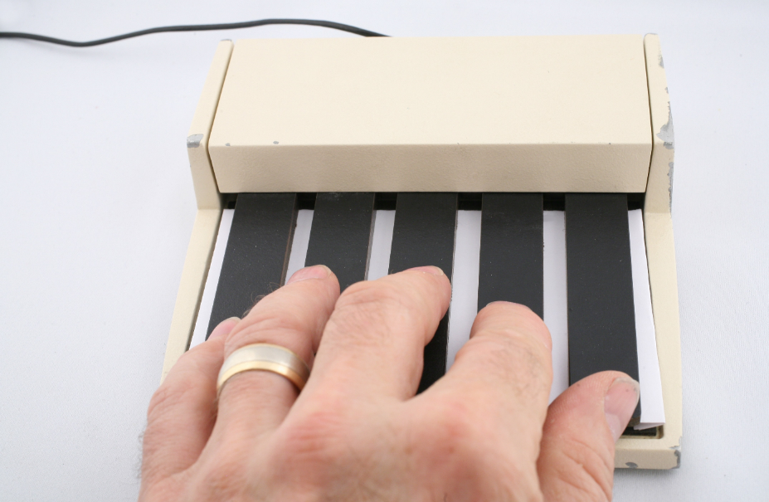

Xerox PARC 5-Button Keyset & 3-Button Mouse (1973)This combination is derived from the work of the inventor of the mouse, Doug Engelbart

While these are 2 distinct devices, they are not what they appear to be.

Functionally, there is a virtual 7-button chord keyboard, employing the 5 buttons on the keyset and the middle and right button of the mouse. And, using the left mouse button, there is also a 1-button mouse

Text was entered using a minor variant of 7-bit ASCII. The intent was to enable entering small bits of text without moving back-and-forth between mouse and QWERTY keyboard. It didn’t catch on.

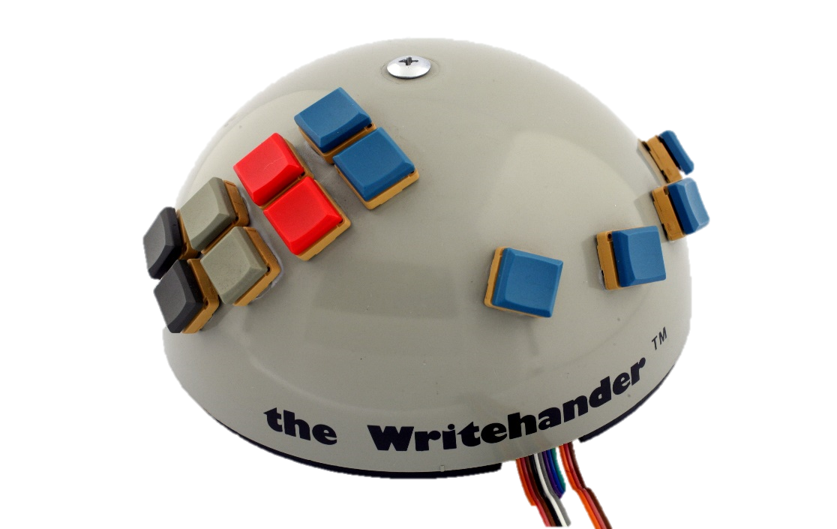

NewO Writehander (1978)

No, this is not a mouse with an abundance of buttons. It is a left-handed chord keyboard employing a different approach to entering text using 7-bit ASCII code.

The challenge addressed is how to do so with one hand (the left one with this version), given one only has 5, rather than 7 fingers.

The hand’s 4 fingers sit over the four blue buttons along the edge on the right. They enter the 4 low-order bits. Pressing one of the other keys enters one of the combinations of the high order 3 bits. Still hard, but if you only have one hand ….

Xerox PARC PARCtab (1992)

This is a project for which I did much of the ergonomic design. The form factor is based on a trumpet, with the 3 buttons on the end substituting for the trumpet valves. Like the trumpet, the chording combinations then give access to 7 virtual buttons from 3 physical ones. The buttons can be operated by the holding hand leaving the other hand free to interact with the screen, for example. The device is also symmetric so that it works equally well in either hand.

The PARCtab was part of the Ubicomp project at Xerox PARC.

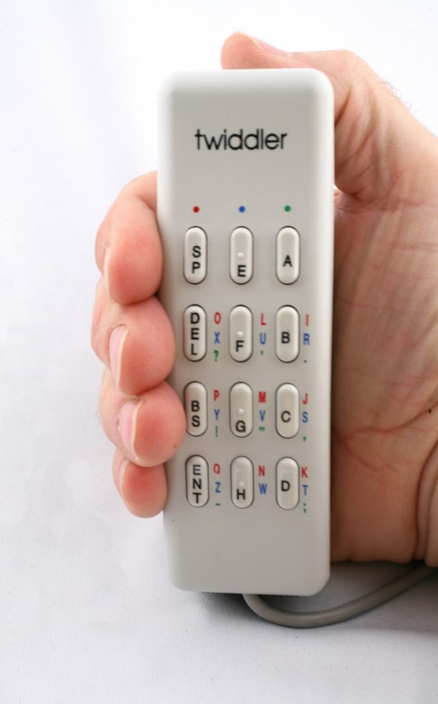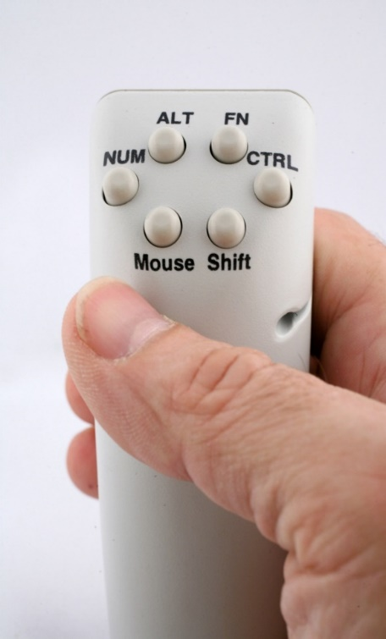

Handykey Twiddler (1991)

This is a one-handed chording keyboard. It was intended to be used while mobile. Hence, it included a strap to hold in place so it could still be operated with one hand while moving about. Besides text entry, it also had the capacity to provide mouse-like functionality.

The Twiddler became a kind of “Standard” means of input for early cyborgs, enabling them to easily interact with the content on the head-mounted displays.

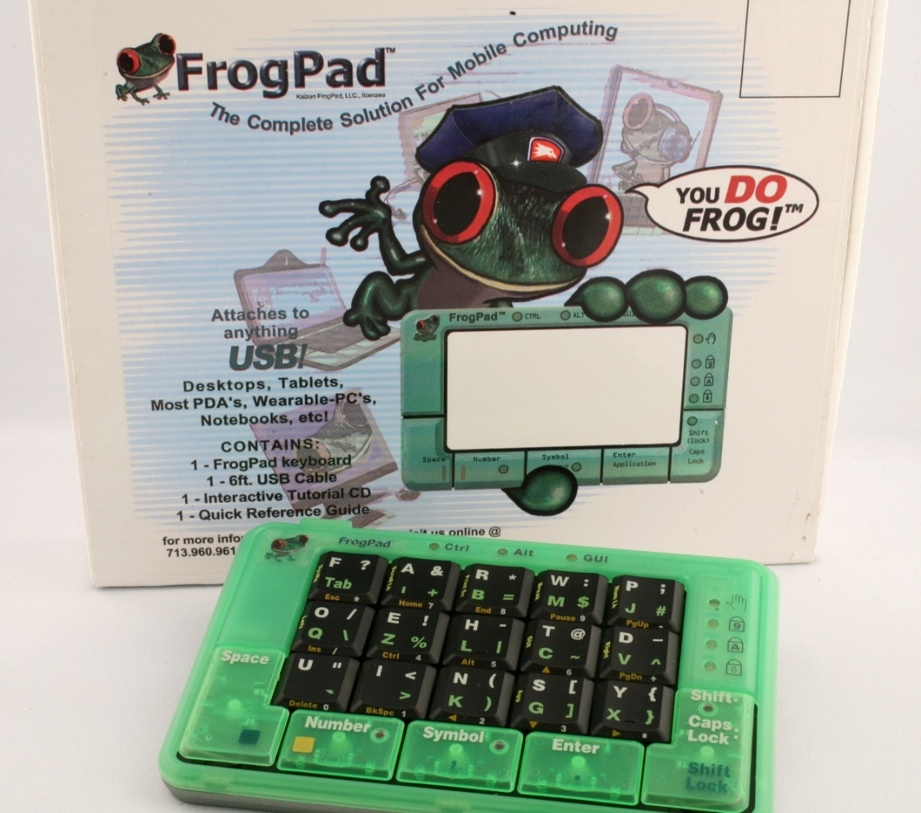

Frog Pad (2002)

This is a one-hand chord keyboard, available for the left or right hand. Driving the design is ease of learning. Because of the reliance on chord combinations, key-cap labels are kind of useless with most chord keyboards. You typically can’t “hunt and peck”. If you can touch type, you can type. Otherwise, you are out of luck until you memorize the chords. Here, by having 20 labelled keys, and chords restricted to 2 buttons, the design strove to find a good compromise to facilitate learning at the expense of keyboard size.

Tap Systems The Tap

Tap is a one-handed wearable device which enables any surface to become both a chord keyboard and a mouse alternative. It does so by instrumenting the hand rather than the tapped surface. This is accomplished by the user wearing a sensor ring on each digit of one hand. This enables one to type into any Bluetooth device, such as a slate, mobile or any device which might otherwise use a regular QWERTY keyboard. Furthermore, like the Twiddler and the PARC keyset-mouse combination, it can also function as a mouse substitute. The same physical device can work on either hand.

END